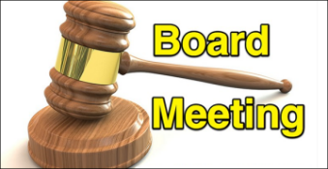
Thursday, August 14, 2025, 6:00 pm
SOS ACADEMY CHARTER MIDDLE SCHOOL 102
VIRTUAL ANNUAL GOVERNANCE BOARD MEETING

- CALL TO ORDER/VERIFICATION OF QUORUM – Quorum present
Members present: Mark Ansley, Fredrick McClendon, Reginald Gaffney, Brenda Wims

- WELCOME/PRAYER/PLEDGE OF ALLEGIANCE
Welcome by Principal Mills, Prayer by Mrs. Scott and The Pledge of Allegiance by Dr. Price.

- APPROVAL OF 5-1-25 Quarterly Meeting Minutes
It was first moved by Fredrick McClendon and seconded by Brenda Wims to approve the May 1, 2025, quarterly meeting minutes. Motion carried.

- ANNOUNCEMENTS - None
- PUBLIC INPUT – N/A

- Charter Requirements – subheadings that need to be approved by SOS Board (4a and 6a&b)
4. Approval OOF Teachers – Ms. Hill introduced to the board, the new hires and presented the returning staff for the 25-26 school year. Ms. Hill also presented to the board the list of Out of Filed Teachers that needed board approval:

TEACHER NAME | CURRENT AREA OF CERTIFICATION | OUT OF FIELD SUBJECT AREA
Donald, Natalie | Social Science 5-9 | Language Arts
Reed, Warren | Math 5-9 | Science
Starkes, Raymond | Business Education 6-12 | Math
Walker, Jamie | Physical Education K-12 | Science

Ms. Hill stated to the board that these teachers are participating in continued education courses to expand their certification to include their current teaching assignment.

6. Approval of Financial Activities Report: Director Mills & Mrs. Kaye Hill
a. Ms. Mills presented to the board SOS Academy’s preliminary budget stating that the student enrollment numbers were less than we anticipated them to be and the school’s budget would be adjusted after the first 20 days of school.
b. Ms. Hill presented to the board SOS Academy’s financials for year ending June 30, 2025. Ms. Hill stated to the board that even though the school’s fund balance for fiscal year June 30, 2025 is still in the black, for the past 3 years SOS’s expenditures are more than the revenues the school is generating.
c. Ms. Hill also presented to the board the Audit Engagement Letter from Herman Vidal, LLC for the fiscal year June 30, 2025 for board approval.


MOTION
It was first moved by Reginald Gaffney and seconded by Brenda Wims to approve the following reports. Motion was carried.
2025-2026 SOS Staff
out of field teachers- Mr. Reed (Science) Mrs. Donald (Science), Mr. Starks (Math), Ms. Walker (Science)
Vendor contracts with PlayWorks Therapy and to approve the Policy on Wireless Communication and Other Electronic Devices, the Policy on Staff Arrest Reporting, the Student Welfare Policy and the Threat Management Policy.
2025 Audit Engagement Letter
2025 – 2026 Proposed Preliminary Fall Budget
Quarterly Financial Repo

- COMMENTS FROM PARENT ORGANIZATIONS - Dr. Sharolyn Price
- PFEP Activities Beginning of the Year Report (2025-2026 PFEP Plan & Budget)
The five approved activities for the upcoming year:
Title I Annual Meeting / Open House, Tuesday, 9-9-25
Literarcy Night / Book Fair – Thursday, 11-13-25
8th Grade Transition to High School, Thursday, 1-22-26
Academic & Data Night – Thursday, 2-19-26
Title I Developmental Meeting, 4-9-26

Explanation of the PFEP Budget
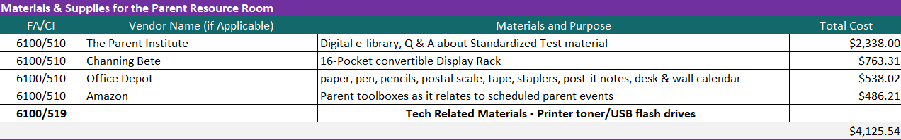
5 meetings required by the District(with light refreshments) ($160 X 5= $800.00)
160.00 X 5 = $800.00
TOTAL = $5,000.00

- OLD BUSINESS – Director Mills

- BTAT (Behavior Threat Assessment Team) & Active Assailant Drills & Fire Drills Monthly
SOS Threat Assessment Team includes Chair, Dean Ronnie Swilling (SOS Staff), Co-chair, Mr. Warren Reed (SOS Staff), JSO Police Officer Mark Flores, Mrs. Gazzara-Keels (SOS Staff), and Ms. Huntsinger (SOS Staff). The team meets monthly; all members have been trained and have received their certificates.

Ms. Mills also mentioned that SOS Staff are required to take five online courses mandated by the FL State Board of Education and the District: Code of Ethics, FL Mandatory Reporter Training, Sexual Misconduct: Staff to Student, Title IX Training for Teachers and Non-Instructional Staff 2025-2026, and Sexual Harassment: Staff to Staff. A certificate is issued upon completion of the course.

NEW BUSINESS: Director Mills
- SOS Clearinghouse Access for fingerprinting & Background Checks
Schools no longer have the option of going through the District for fingerprinting. Every school is required to have its own fingerprinting system, and all individuals must be re-fingerprinted. SOS is in compliance because all staff members have completed the fingerprinting process. Board members will receive the information for fingerprinting.

- PRINCIPAL/DIRECTOR’S REPORT: Ms. Genell Mills
- 2025 -2026 MASTER SCHEDULE

- 2025-2026 SIP & CNA GOALS & continuing Improvement (published) monitoring
The SIP plan was submitted August 1, 2025.
ACADEMIC GOAL:
If SOS implements a data driven instructional program, that encompasses differentiated instruction and is comprehended by all stakeholders, then SOS will improve in the following areas:
1. Student academic achievement in all areas,
2. Greater ability in accessing multiple informational text & identifying discipline specific vocabulary,
3. The number of students making yearly gains and
4. Continuing to improve School Grade

NON-ACADEMIC GOAL:
If SOS implements a student/classroom management system that creates a positive school culture which allows ever student to be safe and successful and is comprehended by all stakeholders, then SOS will improve in the following areas:
- Academics Performance ,
- Appropriate student behavior in all areas,
- Parental involvement/support and,
- School Pride
- School/Community Relations producing Future Leaders of Tomorrow

- FOOD SERVICE CONSULTANT REPORT:
A. Dr. James Young (Turnaround Solutions Inc.)

- ASSISTANT PRINCIPAL: TESTING, CURRICULUM & INSTRUCTION REPORT: Scott
- Testing- FAST Testing 2025-2026 Review

- Testing Calendar 2025-2026
- PM1, PM2, and PM3
- HMH Baseline testing

- 2025 – 2026 CURRICULUM

- Houghton Mifflin Harcourts (HMH)- ELA Reading, Math, Science Social Studies
- McGraw Hill- Civics & Civics EOC Prep
- Penda Learning Science- Supplemental Resource ( 8th)

- F.A.S.T SPRING 2025 PM3 SUMMARY RESULTS
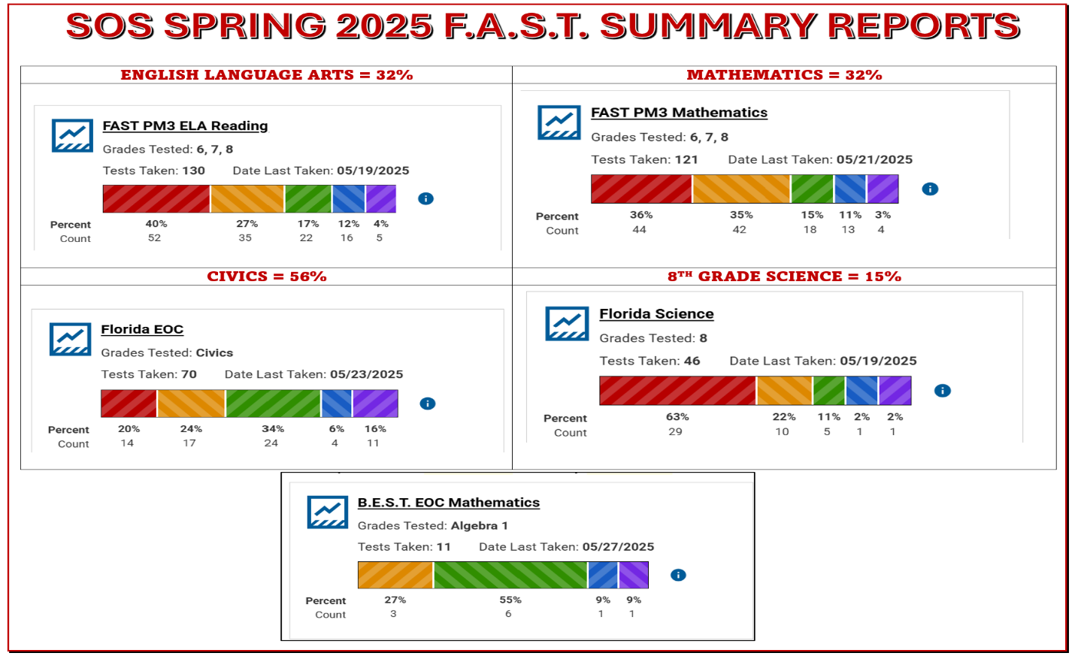

- ASSISTANT PRINCIPAL/DEAN OF STUDENTS: Mills
- Attendance, Enrollment, School-wide Discipline, Transportation, Health & Welfare Reports
102 Enrolled: 24 sixth graders, 37 seventh graders, 41 eighth graders
- Extra-Curricula Activities/Athletics

Charter Requirements – subheadings that does not need approval by the SOS Board:

- Approval of Contract arrangements/Policy & Procedures – N/A
- Purchases that should appear on fixed assist list – update – N/A

- Approval for asset disposals – N/A

- Professional & H.R. Services (Doesn’t need Board Approval): Hill – N/A

- Business /Legal Services/Report (Doesn’t need Board Approval): Hill – N/A

- Approval for Financial Activities Report(Doesn’t need Board Approval) : Mills & Hill– N/A
- Facility Report: Update – N/A

- Extra-Curricular Activities/Athletics: Dean Swilling

- Board Information/Activities: Mills
- NA

MOTION TO ADJOURN at 7:51 pm

MEETING FILE AUGUST 14, 2025:
(Board Meeting Agenda, May 1, 2024, Minutes, SOS Quarterly Financials, SOS 2025-2026 Current Proposed Fall Budget, Spring 2025 FAST Academic Summary of PM3 Performance Data, and 2025-2026 Testing & Professional Development Calendars.)

2025 – 2026 School Motto
“B”
LEVELING & SOARING UP TO A
LEVEL UP IN
Academics
Achievement
Advancement

